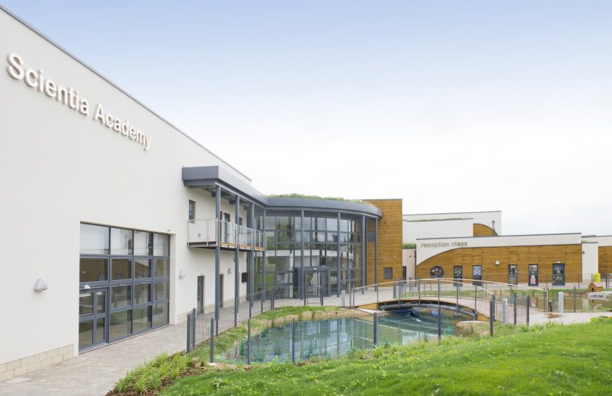
Receptionist / Admin Assistant Application Pack

Contents
Letter from Catherine Paine, Chief Executive Designate 3
Our Cornerstones and Touchstones 5
The role 7
The application 9
The application process and timetable 9
Safeguarding, Safer Recruitment and Data Protection 10
Job Description 11
Person Specification 13

Letter from Catherine Paine, Chief Executive Officer

Dear Candidate
Thank you for your interest in this role within the REAch2 Academy Trust.
This is a hugely exciting time for our family of schools. The Trust has been recognised by the Department for Education as being well placed to raise standards and achieve excellence for pupils in a growing number of schools nationwide. We are presented with a rare opportunity to make a real difference to the lives and life chances of so many primary school children – many of whom haven’t previously received the educational opportunities they deserve.
The Trust includes schools at all stages of development, from those requiring significant improvement through to existing outstanding schools. As a Trust we are clear about the importance of achieving long term sustainability for our schools. Our vision is to enable individual academies to flourish with real autonomy, whilst also ensuring a strong ethos of support and collaboration across our schools.
Employees within REAch2 belong to a national community of professionals, and benefit from a wide range of networks and development opportunities across the Trust. In time, our best teachers are able to work across schools, develop specialisms and step up to leadership roles within and beyond their own academy. The Trust provides a strong culture of collaboration and support, together with high expectations for staff and pupils alike.
Those we recruit are able to demonstrate that they share our values, are highly motivated to work with colleagues within and beyond their school to continuously develop their skills and pursue professional excellence and are committed to providing the highest standards of teaching for all children. If that is you then we would be delighted to receive your application.
Catherine Paine

CEO

Our Cornerstones and Touchstones

REAch2 is the Cornerstone of the Trust: providing a strong, responsible foundation from which every academy develops and grows. A cornerstone provides a subtle yet paramount role in the construction of a building and ensures that REAch2 is a trustworthy, accountable and inspirational organisation, delivering the best possible learning experience.
REAch2 is defined by the values of excellence, quality, delivery and standards – these features give the Trust its enduring attributes and its inherent reliability.
However, what gives each REAch2 Academy its uniqueness are the Touchstones of the Trust (seen on the right). Just as 500 years ago touchstones were used to test the quality of the gold they marked, so too our touchstones find what is precious and set these things apart. They are used to express the values and ethos of the Trust and describe what the Trust wants to be known for and how it wishes to operate.
With good leadership, we aspire to develop children academically, emotionally, physically and spiritually. We notice talent and spot the ‘possible’ in people as well as the ‘actual’. Developing potential across our Trust becomes a realisation that there is a future worth pursuing for everyone.
Children deserve enjoyment in their learning and the pleasure that comes from absorption in a task and achieving their goals. Providing contexts for learning which are relevant, motivating and engaging, release in children their natural curiosity, fun and determination.
Inspiration breathes energy and intent into our schools: through influential experiences, children can believe that no mountain is too high and that nothing is impossible.
REAch2 serves a wide range of communities across the country and we celebrate the economic, social, cultural and religious diversity that this brings: embracing inclusion ensures that we are a Trust that serves all, believing that everyone can succeed.
We take our responsibility seriously. We act judiciously with control and care. We don’t make excuses, but mindfully answer for our actions and continually seek to make improvements.
REAch2 is a Trust that has a strong moral purpose, our integrity is paramount. Our mission is to change children's lives by providing the very best quality education we can. Through this, children can fulfil their potential, become happy, successful adults and contribute effectively and meaningfully to society. We welcome the fact that all our decisions and actions are open to scrutiny. You can learn more about REAch2 at our website: www.reach2.org

Letter from Miss Helen Bye, Headteacher, Scientia Academy REAch2 Academy Trust

Dear Candidate
Scientia Academy is a two-form entry primary school providing a part time morning and afternoon Nursery. We offer a friendly and stimulating environment, where children are encouraged to become confident, caring, articulate and independent learners on their journey to secondary education and use their abilities to the full. We provide a calm and happy atmosphere and set high standards of respect, courtesy, hard work and achievement for all children and adults.
The school is equipped with modern purpose-built classrooms, state of the art ICT suite and 4D cinema an extensive library, art and craft rooms in an expertly designed learning environment. We offer extended school services, which include Breakfast and After School Clubs. Enriching the curriculum as much as possible through educational and residential trips, visiting speakers and professionals drawing upon the local and wider community. Parents are encouraged to become actively involved in their children’s learning through regular coffee mornings, termly review days.
We are very proud of the social and cultural diversity of our school. The children and staff come from a variety of backgrounds and cultures and we aim to celebrate the richness that this brings to the school. This diversity is reflected in our curriculum, our policies and procedures and our school environment.
At Scientia the staff are committed to provide excellence in teaching and learning for every child in our school. We are looking for people who will bring these traits to our school as well as complementing the collegial atmosphere that already exists here at Scientia. If you feel that Scientia is the right type of environment for you then we would love to hear from you.
Miss Helen Bye
Headteacher, Scientia Academy REAch2 Academy Trust

The Role

Post: Receptionist / Admin Assistant
Employer – Reach2 Academy Trust Scientia Academy
Location – Scientia Academy, Mona Road, Burton on Trent, DE13 0UF
Hours – 32.5 hours per week negotiable, Term Time Only excluding 5 Inset Days
Contract – Part-Time, Permanent

Salary – Staffordshire NJC Grade 3, sp 3 to 4 / Full time Equivalent Salary £20,812 to £21,189 per annum (pro-rata)

Start Date – As soon as possible.

About The Role:
Would you relish the exciting opportunity to join our team on a journey towards being an outstanding Academy?
We are seeking to appoint a reliable, organised enthusiastic and highly motivated Receptionist & Admin Assistant. A positive and flexible approach with a customer service background and knowledge of Microsoft Office is essential. You would be joining a team who work hard to provide quality finance/administrative support across the school.
You will provide a professional and efficient customer service whilst ensuring safeguarding procedures are adhered to. You will contribute to the maintenance of school information databases and filing systems relating to pupils ensuring records are accurate and up to date while providing general administrative support. You will build positive relationships with children, parents, staff and the wider community. Sensitive issues will be dealt with professionalism while ensuring confidentiality is observed at all times.
What we are looking for:
We are looking for a team player who has a keen eye for detail, good organisational skills and be able to work under pressure using own initiative.
This is a unique opportunity to join a diligent, fast-paced and dynamic team and we look forward in receiving your application.

The successful candidate must:
- NVQ 2 Business and Administration or equivalent qualification or relevant experience,
- Have excellent interpersonal and organisational skills,
- be flexible and reliable with a caring nature,
- have good knowledge of Microsoft Office and MIS,
- demonstrate accuracy and attention to detail,
- be able to work as part of a successful, hardworking and dedicated team.

In return we can offer:
- an extremely supportive, friendly team and a modern, well-resourced work environment,
- high expectations of pupil behaviour and achievement,
- a commitment to wellbeing and a chance to be a part of a driven, skilled, and dedicated team.
- membership of the Local Government Pension Scheme,
- high quality Continuous Professional Development,
- free and confidential access to REACh2’s Employment Assistant programme manned by qualified counsellors 24 hours / 7 days per week,
- a rewarding job where no two days are the same.

This is an exciting opportunity, and we look forward to receiving your application.
Visits to the school are available, please email recruitment@scientia-academy.org.uk to arrange a suitable time.

The Application
You are invited to submit an application form to Marion Chimenes, School Business Manager, recruitment@scientia-academy.org.uk .

REAch2 Academy Trust have an Equal Opportunities Policy for selection and recruitment. Applicants are requested to complete the Trust’s online Equality & Diversity Monitoring Form separately.

In accordance with our Safeguarding Policy the successful candidate will be required to have an enhanced DBS check.

The application process and timetable

Application deadline: | Sunday 5th February 2023
Interviews: | Week beginning 13th February 2023
Salary: | Staffordshire NJC Grade 3 SCP 3 to 4 / Full time Equivalent Salary £20,812 to £21,189 per annum (pro-rata)
Start date: | As soon as possible

The candidates selected for interview will be informed after shortlisting and full details of the interview programme will be provided.

Safeguarding, Safer Recruitment and Data Protection
At REAch2 we recognise that those who work in an academy are in a unique position in their care of children. The responsibility for all staff to safeguard pupils and promote their welfare, as stated in Section 175 of the Education Act (2002) is one that is central to our ethos, our policies and our actions. All children are deserving of the highest levels of care and safeguarding, regardless of their individual characteristics or circumstances, and we are committed to applying our policies to ensure effective levels of safeguarding and care are afforded to all our pupils.

We will seek to recruit the best applicant for the job based on the abilities, qualifications, experience as measured against the job description and person specification. The recruitment and selection of staff will be conducted in a professional, timely and responsive manner and in compliance with current employment legislation, and relevant safeguarding legislation and statutory guidance.

All information is stored securely and any information supplied by unsuccessful candidates will be destroyed through a confidential waste system six months after the decision has been communicated, in accordance with our information and records retention policy.

The Trust ensures all applicant data is stored and processed appropriately. For further details on how your information will be managed during the recruitment process please refer to our Privacy Notice for Job Applications.

Job Description

Job Title: Receptionist & Admin Assistant Level 2
Salary: Grade 3, point 3 to 4
Responsible to: School Business Manager/Headteacher

Statement of Purpose
To work under the direction and instruction of senior staff to provide reception, first aid and general clerical support to the school.
Support to Reception
- To provide an efficient reception service to all visitors to the school and members of the school community
- To ensure that all visitors to the school are signed in and out and provided with the correct visitor badge as required and ensuring safeguarding procedures are adhered to.
- To answer all telephone enquiries promptly and take messages as necessary to pass on to the appropriate person.
- To assist with general clerical duties, such as filing and distribution of letters, printer management and access cards for staff as and when needed.
- To assist with the register and attendance when required.
- Other appropriate duties relevant to the purpose of the post and within the grading and competency of the post holder, as reasonably required by the School Business Manager/Headteacher.
Support for Data Management
- To maintain manual and computerised records/management information systems and respond to queries.
- Make data available to stakeholder at the appropriate time, e.g. parents, students, teachers, LEA, DCSF, other external agencies at the appropriate time.
- Ensure the integrity of all data held in the school.
- Ensure data is input in a consistent and accurate manner onto all data systems.
- Assist with the analysis of data produced, and produce reports and documentation for the Senior Leadership Team, governors or other stakeholders as required.
- Provide data and produce reports in a timely manner to meet internal and externally set deadlines.
- Produce regular reports to meet statutory requirements and deadlines.

Professional Accountabilities
The post holder is required to be aware of and comply with policies and procedures relating to child protection, health, safety and security, confidentiality and data protection, reporting all concerns to an appropriate person. In addition they are to contribute to the achievement of the school’s objectives through:
Safeguarding
- Promote and safeguard the welfare of children and young persons you are responsible for or come into contact with.

Financial Management
- Personally accountable for delivering services efficiently, efficiently within budget and to implement any approved savings and investment allocated to the service area.

People Management

- To comply and engage with people management policies and processes
- Contribute to the overall ethos/work/aims of the school.
- Establish constructive relationships and communicate with other agencies/professionals.
- Attend and participate in regular meetings.
- Participate in training and other learning activities and performance development as required.
- Recognise own strengths, areas of expertise and use these to advise and support others.

Equalities
- Ensure that all work is completed with a commitment to equality and anti-discriminatory practice, as a minimum to standards required by legislation.

Health and Safety
- Ensure a work environment that protects people’s health and safety and that promotes welfare and which is in accordance with the Academy Health and Safety policy.

Note 1:
The content of this job description will be reviewed with the post holder on an annual basis in line with the School’s performance and development review policy. Any significant change in level of accountability that could result in a change to the grade must be discussed with the post holder and the relevant trade union before submitting for re-evaluation.
Person Specification  Criteria | Measured by
Experience  - General clerical/administrative work.  - Experience of data manipulation, analysis and reporting.  - Proven ICT experience.  - Proven track record of providing an effective and efficient reception service. | I
Qualifications  - NVQ 2 Business and Administration or equivalent qualification or experience in relevant discipline.  - Good numeracy and literacy skills. | AF/I
Knowledge / Skills  - Excellent Keyboard and Computer skills (training will be given on the school system SIMS).  - Organisational Skills  - The ability to remain calm under pressure  - Motivated  - Customer focused  - Confidential approach is essential  - Ability to work as part of a team and on own initiative.  - Awareness of relevant legislation.  - Methodical with a good attention to detail. | AF/I
Behaviour Attributes
- Customer focused.
- Has a friendly yet professional and respectful approach which demonstrates support and shows mutual respect.
- Open and honest and an active listener.
- Takes responsibility and accountability
- Committed to the needs of the pupils, parents and other stakeholders and challenge barriers and blocks to providing an effective service.
- Demonstrates and “can do” attitude including suggesting solutions, participating, trusting and encouraging others and achieving expectations.
- Is committed to the provision and improvement of quality service provision.
- Is adaptable to change/embraces and welcomes change.
- Acts with pace and urgency being energetic, enthusiastic and decisive.
- Communicates effectively.
- Has the ability to learn from experiences and challenges.
- Evidence of a commitment to safeguarding and promoting the welfare of children and young people.
- Is committed to the continuous development of self and others by keeping up to date and sharing knowledge, encouraging new ideas, seeking new opportunities and challenges, open to ideas and developing skills.
- Commitment to promote and support the aims of the School and of the Trust.

AF = Assessed at Application Form I = Assessed at Interview T = Assessed through Test
Note 1:
In addition to the ability to perform the duties of the post, issues relating to safeguarding and promoting the welfare of children will need to be demonstrated these will include:
- Motivation to work with children and young people.
- Ability to form and maintain appropriate relationships and personal boundaries with children and young people.
- Emotional resilience in working with challenging behaviours and
- Attitudes to use of authority and maintaining discipline.

I have read and understand my job description.
__________________________________ _____________________
Employee Name Employee Signature
Date………………………………..

____________________________________ _____________________
Headteacher Name Headteacher Signature
Date………………………………….

