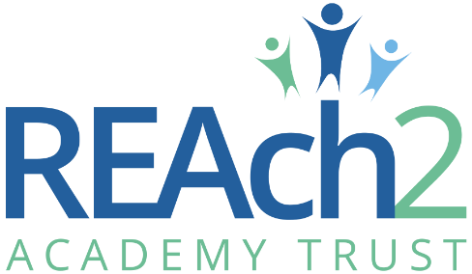
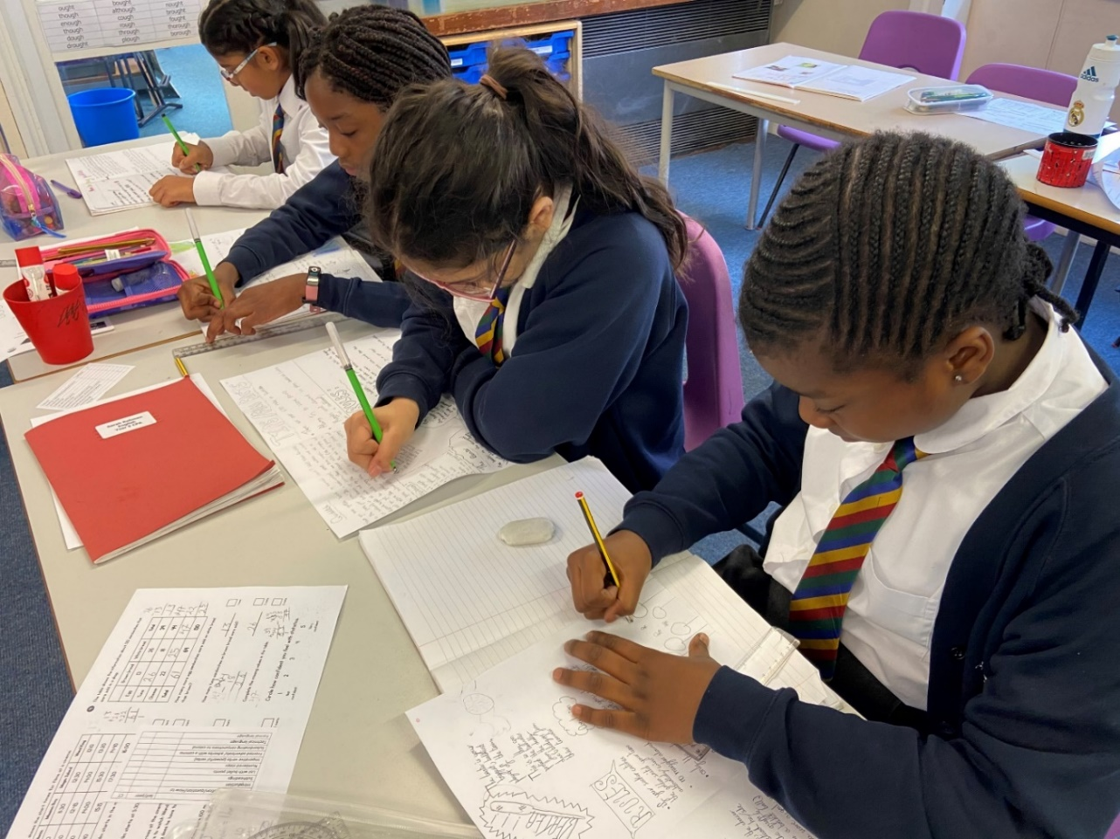
Class Teacher
Application Pack

Contents
Letter from Catherine Paine, Chief Executive Officer 3
Letter from Stuart Norman, Chair of Governors, Chigwell Pirmary Academy 4
Our Cornerstones and Touchstones 5
The role 7
The application 9
The application process and timetable 9
Safeguarding, Safer Recruitment and Data Protection 10
Job Description 11

Letter from Catherine Paine, Chief Executive Officer

Dear Candidate
Thank you for your interest in this role within the REAch2 Academy Trust.
This is a hugely exciting time for our family of schools. The Trust has been recognised by the Department for Education as being well placed to raise standards and achieve excellence for pupils in a growing number of schools nationwide. We are presented with a rare opportunity to make a real difference to the lives and life chances of so many primary school children – many of whom haven’t previously received the educational opportunities they deserve.
The Trust includes schools at all stages of development, from those requiring significant improvement through to existing outstanding schools. As a Trust we are clear about the importance of achieving long term sustainability for our schools. Our vision is to enable individual academies to flourish with real autonomy, whilst also ensuring a strong ethos of support and collaboration across our schools.
Employees within REAch2 belong to a national community of professionals, and benefit from a wide range of networks and development opportunities across the Trust. In time, our best teachers are able to work across schools, develop specialisms and step up to leadership roles within and beyond their own academy. The Trust provides a strong culture of collaboration and support, together with high expectations for staff and pupils alike.
Those we recruit are able to demonstrate that they share our values, are highly motivated to work with colleagues within and beyond their school to continuously develop their skills and pursue professional excellence and are committed to providing the highest standards of teaching for all children. If that is you then we would be delighted to receive your application.
Catherine Paine

CEO

Letter from Stuart Norman, Chair of Governors
Dear Candidate

Thank you for your interest in the role of class teacher at Chigwell Primary Academy.

Chigwell Primary Academy is a 1 form entry EYFS/KS1 increasing to 1.5 form entry in KS2 school at the heart of our community where we nurture and support children of all abilities, helping each to achieve their potential in all aspects of learning and physical, social, emotional, moral, and spiritual development. From this foundation we encourage our staff to share success and equip our children to become independent, creative thinkers and learners for life and to develop their resilience to face the challenges of an ever-changing world.

We recognise and value the diversity of our school family and the uniqueness of each of its members. We ensure excellence in teaching and learning through teamwork, support, collaboration, and effective leadership. We promote inclusion, creativity, and enthusiasm. And the importance of British values – including tolerance, cooperation, trust, and respect – within the school and the wider community.

We actively encourage community involvement wherever possible. Achieving the best, we can for our children by using the strength of partnership working with parents and other stakeholders both within and outside of our immediate community.

This is an exciting time for Chigwell with the school having been accepted for the DfE Priority School Rebuilding Program. This brings a fantastic opportunity not only for a new modern school building but the exciting opportunity to enhance our senior leadership structure with a Deputy Headteacher. We are now seeking an outstanding practitioner with the passion, experience, and vision to join our leadership team in moving our school forward, building on the considerable successes that have been achieved in recent years without losing our inclusive and supportive ethos.

Chigwell is a school where we are proud to have developed a brilliant, warm, and welcoming place to work and to learn. We have fantastic children and wonderful dedicated staff and governors, and if you would like to be part of our continuing journey of excellence, we look forward to hearing from you.

Stuart Norman, Chair of Governors, Chigwell Primary Academy

Our Cornerstones and Touchstones

REAch2 is the Cornerstone of the Trust: providing a strong, responsible foundation from which every academy develops and grows. A cornerstone provides a subtle yet paramount role in the construction of a building and ensures that REAch2 is a trustworthy, accountable and inspirational organisation, delivering the best possible learning experience.
REAch2 is defined by the values of excellence, quality, delivery and standards – these features give the Trust its enduring attributes and its inherent reliability.
However, what gives each REAch2 Academy its uniqueness are the Touchstones of the Trust (seen on the right). Just as 500 years ago touchstones were used to test the quality of the gold they marked, so too our touchstones find what is precious and set these things apart. They are used to express the values and ethos of the Trust and describe what the Trust wants to be known for and how it wishes to operate.
With good leadership, we aspire to develop children academically, emotionally, physically and spiritually. We notice talent and spot the ‘possible’ in people as well as the ‘actual’. Developing potential across our Trust becomes a realisation that there is a future worth pursuing for everyone.
Children deserve enjoyment in their learning and the pleasure that comes from absorption in a task and achieving their goals. Providing contexts for learning which are relevant, motivating and engaging, release in children their natural curiosity, fun and determination.
Inspiration breathes energy and intent into our schools: through influential experiences, children can believe that no mountain is too high and that nothing is impossible.
REAch2 serves a wide range of communities across the country and we celebrate the economic, social, cultural and religious diversity that this brings: embracing inclusion ensures that we are a Trust that serves all, believing that everyone can succeed.
We take our responsibility seriously. We act judiciously with control and care. We don’t make excuses, but mindfully answer for our actions and continually seek to make improvements.
REAch2 is a Trust that has a strong moral purpose, our integrity is paramount. Our mission is to change children's lives by providing the very best quality education we can. Through this, children can fulfil their potential, become happy, successful adults and contribute effectively and meaningfully to society. We welcome the fact that all our decisions and actions are open to scrutiny. You can learn more about REAch2 at our website: www.reach2.org

The role

Class Teacher

Required for: September 2023
Location: Chigwell Primary Academy, Mandir Lane, Chigwell, Essex, IG7 6ED
Salary: Main Scale/Upper Pay Scale
Closing Date: Applications will be considered on arrival
Interviews: Ongoing as applicants are shortlisted

We are looking for an exceptional teacher who currently demonstrates credibility in all learning and teaching practice to all in their current school.
Learning and teaching will be your passion in action, with a genuine desire for all children to achieve of their best as learners and people with your support. You will be a reflective practitioner willing and able to evolve our learning and teaching practice to meet the needs of our growing and ever-changing community of children. We will ensure that we enable excellence for all in our school.
Do you:
• believe passionately that all children should be enabled to reach their full potential?
• have a passion for the high-quality teaching of a well-planned and carefully sequenced curriculum?
• motivate and inspire through creative and innovative teaching?
• want to work for a leadership team who put well-being first and ensure that staff have a work-life balance?
• want to work for one of the most progressive academy trusts in the UK?
If you have a genuine commitment to improving the life chances of children then we would like to hear from YOU!

We can offer you:
- The opportunity to continue to build our exceptional learning and teaching and personal development offer for our children;
- The opportunity to help continue to build and develop our team and to accentuate the ethos and culture of our school;
- The opportunity to make a difference to children’s lives;
- The chance for your skills to flourish and develop with practical support and encouragement;
- High quality training and development through one of the country’s leading Multi-Academy Trusts;
- The opportunity to work with children from diverse ethnicities and cultures;
- An inclusive ethos where every child is valued and supported to achieve their potential;
- A future career flightpath within REAch2 Academy Trust;
- Friendly, supportive, enthusiastic and hardworking colleagues, staff and Governors

The deadline for applications: Applications will be considered on arrival

Interviews: Ongoing as applicants are shortlisted

Completed Application forms should be returned to Elaine Brook (Executive Headteacher) elaine@reach2.org

The school is committed to safeguarding the welfare of children and expects all staff to share this commitment. This post is subject to an Enhanced DBS with Child’s Barred List check and satisfactory references.

The application
You are invited to submit an application form to Elaine Brook (Executive Headteacher) elaine@reach2.org

REAch2 Academy Trust have an Equal Opportunities Policy for selection and recruitment. Applicants are requested to complete the Trust’s online Equality & Diversity Monitoring Form separately.

In accordance with our Safeguarding Policy the successful candidate will be required to have an enhanced DBS check.

Informal and exploratory conversations are welcomed and encouraged. To arrange an informal discussion please contact Charlotte Furia (Head of School) at charlotte.furia@chigwellprimaryacademy.co.uk to discuss the post in confidence and arrange a visit to the school.

The application process and timetable
Application deadline: | Applications will be considered on arrival
School visits: | Visits to the school are welcome and encouraged, please contact Charlotte Furia, Head of School to arrange
Interviews: | Ongoing as applicants are shortlisted
Contract details: | Permanent
Salary: | Main Scale / Upper Pay Scale
Start date: | September 2023
The candidates selected for interview will be informed after shortlisting and full details of the interview programme will be provided.

Safeguarding, Safer Recruitment and Data Protection

At REAch2 we recognise that those who work in an academy are in a unique position in their care of children. The responsibility for all staff to safeguard pupils and promote their welfare, as stated in Section 175 of the Education Act (2002) is one that is central to our ethos, our policies and our actions. All children are deserving of the highest levels of care and safeguarding, regardless of their individual characteristics or circumstances, and we are committed to applying our policies to ensure effective levels of safeguarding and care are afforded to all our pupils.

We will seek to recruit the best applicant for the job based on the abilities, qualifications, experience as measured against the job description and person specification. The recruitment and selection of staff will be conducted in a professional, timely and responsive manner and in compliance with current employment legislation, and relevant safeguarding legislation and statutory guidance.

All information is stored securely and any information supplied by unsuccessful candidates will be destroyed through a confidential waste system six months after the decision has been communicated, in accordance with our information and records retention policy.

The Trust ensures all applicant data is stored and processed appropriately. For further details on how your information will be managed during the recruitment process please refer to our Privacy Notice for Job Applications.

Job Description
All post-holders are expected to demonstrate a commitment to Equal Opportunities and a proven ability to work effectively in culturally and linguistically diverse classrooms. This person specification is related to the requirements of the post as determined by the job description.
Post: Class Teacher
Responsible to: The Headteacher
Salary/Grade: M1 - UPS

Responsible for:
- Supporting the vision, ethos and policies of the school and promoting high levels of achievement.
- Supporting the creation and implementation of the school improvement plan.
- Organising and managing teaching and learning.
- The development and monitoring of the curriculum provision.
- Supporting the Headteacher in the monitoring of the quality of teaching and children’s achievements.
- The pastoral care of children, promoting independence and good behaviour, in accordance with school policies
- Ensuring that parents are fully involved in their child’s learning and development and well-informed about the curriculum, their child’s individual targets, progress and achievement
- Developing the use of new and emerging technologies and techniques within the classroom

Teaching and Learning
- Identifying clear teaching objectives and specifying how they will be taught and assessed.
- Setting tasks which challenge pupils and ensure high levels of interest
- Setting appropriate and demanding expectations
- Setting clear targets, building on prior attainment
- Identifying SEN or very able pupils
- Providing clear structures for lessons maintaining pace, motivation and challenge
- Making effective teaching and best use of available time
- Maintaining good conduct and learning behaviours in accordance with the school’s procedures and encouraging good practice with regard to punctuality, behaviour, standards of work and homework
- Ensuring effective teaching and best use of available time
- Using a variety of teaching methods to match approach to content, structure information, present a set of key ideas and use appropriate vocabulary
- Use effective questioning, listen carefully to pupils, give attention to errors and misconceptions
- Select appropriate learning resource’s and develop study skills through library, I.C.T. and other sources
- Ensuring pupils acquire and consolidate knowledge skills and understanding appropriate to the subject taught
- Evaluating own teaching critically to improve effectiveness
- Ensuring the effective and efficient deployment of classroom support
- Taking account of pupils’ needs by providing structured learning opportunities which develop the areas of learning identified in national and local policies and particularly the foundations for English and Mathematics
- Encouraging pupils to think and talk about their learning, develop self-control and independence, concentrate and persevere and listen attentively
- Using a variety of teaching strategies which involve planned adult intervention, first-hand experience and play and talk as a vehicle for learning.

Monitoring, Assessment, Recording, Reporting
- Assess how well learning objectives have been achieved and us them to improve specific aspects of teaching
- Provide feedback for pupils and set targets together for progress
- Assess and record pupils’ progress systematically and keep records to check work is understood and completed, monitor strengths and weaknesses, inform planning and recognize the level at which the pupil is achieving
- Prepare and present informative reports to parents.

Curriculum Development
- Contribute to team responsibility for a subject or aspect of the school’s work and develop plans which identify clear targets and success criteria for its development and/or maintenance
- Contribute to the whole school’s development activities
- To lead an area of the curriculum
Additional Requirements:
- REAch2 has a strong commitment to achieving equality of opportunity in its services to the community and the employment of people and expects all employees to understand, comply with and promote its policies in their work and to undertake any appropriate training.
- The post holder is expected to undertake any appropriate training, including recognised professional qualifications, considered necessary to fulfil the role.
- The post holder is expected to demonstrate a flexible approach in the delivery of work.
- Consequently, the post holder may be required to perform work not specifically identified in the job description.
The duties outlined in the Job Description may be varied to meet the changing demands of the school at the reasonable direction of the Headteacher. This job description does not form part of the contract of employment. It describes the way the post holder is expected to perform and complete the particular duties as set out above.
Chigwell Primary Academy is committed to safeguarding and promoting the welfare of children and young people and expects all staff and volunteers to share this commitment. This post is classed as having a high degree of contact with children or vulnerable adults and is exempt from the Rehabilitation of Offenders Act 1974. An Enhanced DBS with Child Barred List check will be sought as part of the Academy’s pre-employment checks.

 | Essential | Desirable | Measured by
Right to work in the UK | *
Knowledge/Qualifications and experience
Qualified Teacher status | * |  | A
Relevant degree | * |  | A
Clear communication/questioning skills – precise approach to written communication | * |  | A O I
ICT competent | * |  | O
Able to inspire children’s interest in learning | * |  | O
A full Enhanced Disclosure from the Disclosure and Barring Service | * |  | A I
Skills , abilities and personal attributes
Evidence of a commitment to safeguarding and promoting the welfare of children and young people | * |  | A R I
Commitment to promote and support the aims of REAch2 | * |  | R I
Knowledge of strategies to support learning, progress and standards across the curriculum – evidence of impact on progress | * |  | A R O I
Knowledge of how ICT can be used to support/ enrich learning | * |  | A
Effective classroom management skills – able to provide an effective environment for learning | * |  | O
Clear understanding of the role of assessment in the development of learning | * |  | A O I
Successful record of teaching within primary | * |  | A O I R
Awareness of national trends and developments | * |  | A I
Evidence of commitment to personal and professional development | * |  | A I
Personal Qualities
Flexibility of approach | * |  | R
Excellent organizational skills | * |  | O R I
Supportive – able to work as part of a team | * |  | R
Able to respond to and seek advice | * |  | R
Ability to work under pressure while maintaining a cheerful disposition | * |  | A O I
Flexibility of approach | * |  | R
Interest & Motivation in the job
Enthusiasm for children’s learning | * |  | O I R A
A commitment to the integration of children with SEN in mainstream school environment | * |  | O I A
A willingness to contribute to all areas of school life | * |  | A R I
*Key: A=Application, R=Reference, O=Observation, I=Interview

When completing the supporting statement applicants should address each of the selection criteria with clear evidence of success.
Chigwell Primary Academy recognises that all individuals have fundamental human rights and therefore adopts a rights-based approach to equality. We shall develop practices that promote the right for everyone to participate in all aspects of life within school by promoting initiatives that remove barriers to participation and by actively promoting equality and social inclusion.
We recognise that prejudice and inequality of opportunity exist within life and we commit ourselves to challenging and redressing these injustices by applying equal opportunity within school.

