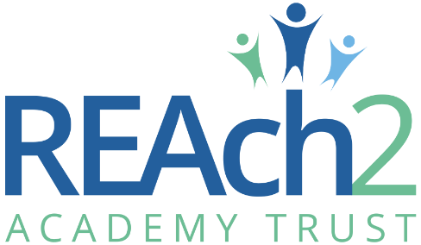
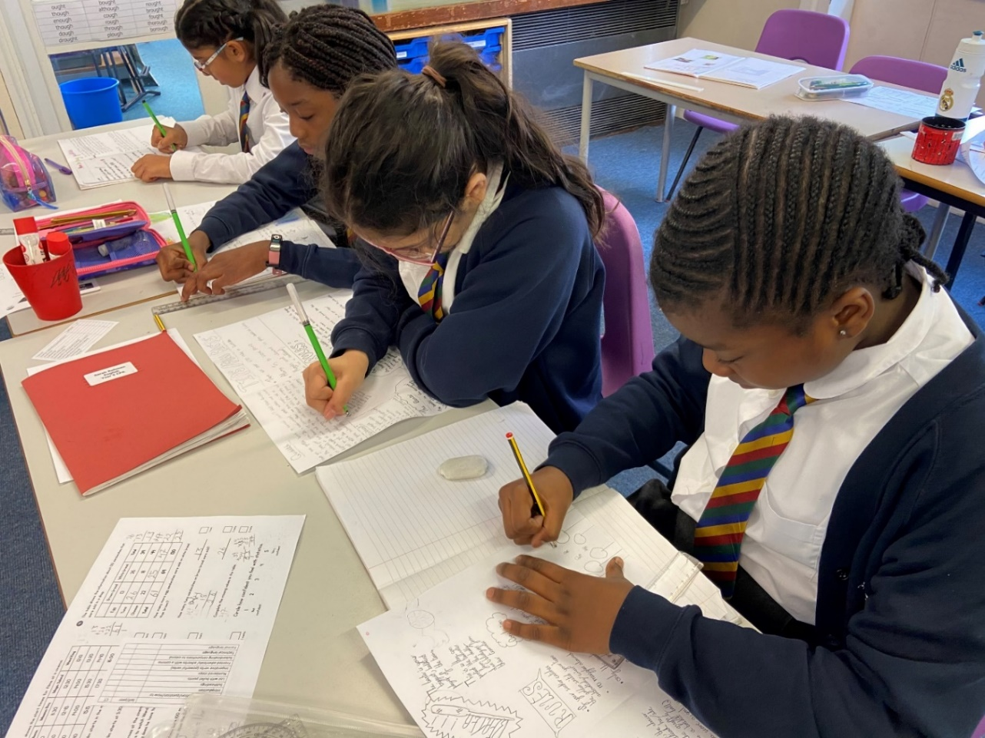
EYFS & KS1 Phase Leader
(Including Phonics Lead)
Application Pack

Contents
Letter from Catherine Paine, Chief Executive Officer 3
Letter from Stuart Norman, Chair of Governors, Chigwell Pirmary Academy 4
Our Cornerstones and Touchstones 5
The role 7
The application 9
The application process and timetable 9
Safeguarding, Safer Recruitment and Data Protection 10
Job Description 11

Letter from Catherine Paine, Chief Executive Officer

Dear Candidate
Thank you for your interest in this role within the REAch2 Academy Trust.
This is a hugely exciting time for our family of schools. The Trust has been recognised by the Department for Education as being well placed to raise standards and achieve excellence for pupils in a growing number of schools nationwide. We are presented with a rare opportunity to make a real difference to the lives and life chances of so many primary school children – many of whom haven’t previously received the educational opportunities they deserve.
The Trust includes schools at all stages of development, from those requiring significant improvement through to existing outstanding schools. As a Trust we are clear about the importance of achieving long term sustainability for our schools. Our vision is to enable individual academies to flourish with real autonomy, whilst also ensuring a strong ethos of support and collaboration across our schools.
Employees within REAch2 belong to a national community of professionals, and benefit from a wide range of networks and development opportunities across the Trust. In time, our best teachers are able to work across schools, develop specialisms and step up to leadership roles within and beyond their own academy. The Trust provides a strong culture of collaboration and support, together with high expectations for staff and pupils alike.
Those we recruit are able to demonstrate that they share our values, are highly motivated to work with colleagues within and beyond their school to continuously develop their skills and pursue professional excellence and are committed to providing the highest standards of teaching for all children. If that is you then we would be delighted to receive your application.
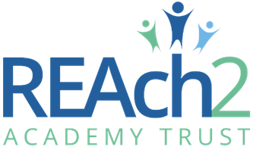
Catherine Paine

CEO

Letter from Stuart Norman, Chair of Governors
Dear Candidate

Thank you for your interest in the role of EYFS and KS1 Phase leader (including Phonics Lead) at Chigwell Primary Academy.

Chigwell Primary Academy is a 1 form entry EYFS/KS1 increasing to 1.5 form entry in KS2 school at the heart of our community where we nurture and support children of all abilities, helping each to achieve their potential in all aspects of learning and physical, social, emotional, moral, and spiritual development. From this foundation we encourage our staff to share success and equip our children to become independent, creative thinkers and learners for life and to develop their resilience to face the challenges of an ever-changing world.

We recognise and value the diversity of our school family and the uniqueness of each of its members. We ensure excellence in teaching and learning through teamwork, support, collaboration, and effective leadership. We promote inclusion, creativity, and enthusiasm. And the importance of British values – including tolerance, cooperation, trust, and respect – within the school and the wider community.

We actively encourage community involvement wherever possible. Achieving the best, we can for our children by using the strength of partnership working with parents and other stakeholders both within and outside of our immediate community.

This is an exciting time for Chigwell with the school having been accepted for the DfE Priority School Rebuilding Program. This brings a fantastic opportunity not only for a new modern school building but the exciting opportunity to enhance our senior leadership structure with a Deputy Headteacher. We are now seeking an outstanding practitioner with the passion, experience, and vision to join our leadership team in moving our school forward, building on the considerable successes that have been achieved in recent years without losing our inclusive and supportive ethos.

Chigwell is a school where we are proud to have developed a brilliant, warm, and welcoming place to work and to learn. We have fantastic children and wonderful dedicated staff and governors, and if you would like to be part of our continuing journey of excellence, we look forward to hearing from you.

Stuart Norman, Chair of Governors, Chigwell Primary Academy

Our Cornerstones and Touchstones

REAch2 is the Cornerstone of the Trust: providing a strong, responsible foundation from which every academy develops and grows. A cornerstone provides a subtle yet paramount role in the construction of a building and ensures that REAch2 is a trustworthy, accountable and inspirational organisation, delivering the best possible learning experience.
REAch2 is defined by the values of excellence, quality, delivery and standards – these features give the Trust its enduring attributes and its inherent reliability.
However, what gives each REAch2 Academy its uniqueness are the Touchstones of the Trust (seen on the right). Just as 500 years ago touchstones were used to test the quality of the gold they marked, so too our touchstones find what is precious and set these things apart. They are used to express the values and ethos of the Trust and describe what the Trust wants to be known for and how it wishes to operate.
With good leadership, we aspire to develop children academically, emotionally, physically and spiritually. We notice talent and spot the ‘possible’ in people as well as the ‘actual’. Developing potential across our Trust becomes a realisation that there is a future worth pursuing for everyone.
Children deserve enjoyment in their learning and the pleasure that comes from absorption in a task and achieving their goals. Providing contexts for learning which are relevant, motivating and engaging, release in children their natural curiosity, fun and determination.
Inspiration breathes energy and intent into our schools: through influential experiences, children can believe that no mountain is too high and that nothing is impossible.
REAch2 serves a wide range of communities across the country and we celebrate the economic, social, cultural and religious diversity that this brings: embracing inclusion ensures that we are a Trust that serves all, believing that everyone can succeed.
We take our responsibility seriously. We act judiciously with control and care. We don’t make excuses, but mindfully answer for our actions and continually seek to make improvements.
REAch2 is a Trust that has a strong moral purpose, our integrity is paramount. Our mission is to change children's lives by providing the very best quality education we can. Through this, children can fulfil their potential, become happy, successful adults and contribute effectively and meaningfully to society. We welcome the fact that all our decisions and actions are open to scrutiny. You can learn more about REAch2 at our website: www.reach2.org

The role

EYFS & KS1 Phase Leader (Including Phonics Lead)

Required for September 2023
Location: Chigwell Primary Academy, Mandir Lane, Chigwell, Essex, IG7 6ED
Salary: Main Scale/Upper Pay Scale plus TLR2a
Closing Date: Applications will be considered on arrival

We are looking for an exceptional teacher who currently demonstrates credibility in all learning and teaching practice to all in their current school. You would be able to model learning and teaching best practice to others and would be able to demonstrate how you have worked alongside other teachers to guide and support them to continue to develop their learning and teaching practice. We are looking for someone who has experience of ensuring pupils make good progress by the time they leave KS1 and would ideally be and experienced EYFS and KS1 practitioner. Learning and teaching will be your passion in action, with a genuine desire for all children to achieve of their best as learners and people with your support. You will be a reflective practitioner willing and able to evolve our learning and teaching practice to meet the needs of our growing and ever-changing community of children. We will ensure that we enable excellence for all in our school.
As an exceptional leader you will have led a core curriculum subject and/or a year group or phase of a primary school, leading the curriculum practice and development wider than classroom level. You will have a desire and a passion to work alongside the Headteacher and our wider team to further develop our whole curriculum and the individual subjects within it. You will be key in ensuring that our children can articulate the knowledge and skills they have learned over time in our school and hold aspirations for their own exceptional futures.
Our EYFS and KS1 Phase Leader will need to be flexible to the needs of the school. This is a leadership role requiring high visibility around the school and school community, demonstrating and applying strong social and emotional literacy skills.
If you have a genuine commitment to improving the life chances of children then we would like to hear from YOU!
We can offer you:
The opportunity to continue to build our exceptional learning and teaching and personal development offer for our children;
The opportunity to help continue to build and develop our team and to accentuate the ethos and culture of our school;
The opportunity to make a difference to children’s lives;
The chance for your skills to flourish and develop with practical support and encouragement;
High quality training and development through one of the country’s leading Multi-Academy Trusts;
The opportunity to work with children from diverse ethnicities and cultures;
An inclusive ethos where every child is valued and supported to achieve their potential;
A future career flightpath within REAch2 Academy Trust;
Friendly, supportive, enthusiastic and hardworking colleagues, staff and Governors

The deadline for applications: Applications will be considered on arrival

Interviews: Ongoing as applicants are shortlisted

Completed Application forms should be returned to Elaine Brook (Executive Headteacher) elaine@reach2.org

The school is committed to safeguarding the welfare of children and expects all staff to share this commitment. This post is subject to an Enhanced DBS with Child’s Barred List check and satisfactory references.

The application
You are invited to submit an application form to Elaine Brook (Executive Headteacher) elaine@reach2.org

REAch2 Academy Trust have an Equal Opportunities Policy for selection and recruitment. Applicants are requested to complete the Trust’s online Equality & Diversity Monitoring Form separately.

In accordance with our Safeguarding Policy the successful candidate will be required to have an enhanced DBS check.

Informal and exploratory conversations are welcomed and encouraged. To arrange an informal discussion please contact Charlotte Furia (Head of School) at charlotte.furia@chigwellprimaryacademy.co.uk to discuss the post in confidence and arrange a visit to the school.

The application process and timetable
Application deadline: | Applications considered on arrival
School visits: | Visits to the school are welcome and encouraged, please contact Charlotte Furia, Head of School to arrange
Interviews: | Ongoing as applicants are shortlisted
Contract details: | Permanent
Salary: | Main Scale / Upper Pay Scale plus TLR2a
Start date: | September 2023
The candidates selected for interview will be informed after shortlisting and full details of the interview programme will be provided.

Safeguarding, Safer Recruitment and Data Protection

At REAch2 we recognise that those who work in an academy are in a unique position in their care of children. The responsibility for all staff to safeguard pupils and promote their welfare, as stated in Section 175 of the Education Act (2002) is one that is central to our ethos, our policies and our actions. All children are deserving of the highest levels of care and safeguarding, regardless of their individual characteristics or circumstances, and we are committed to applying our policies to ensure effective levels of safeguarding and care are afforded to all our pupils.

We will seek to recruit the best applicant for the job based on the abilities, qualifications, experience as measured against the job description and person specification. The recruitment and selection of staff will be conducted in a professional, timely and responsive manner and in compliance with current employment legislation, and relevant safeguarding legislation and statutory guidance.

All information is stored securely and any information supplied by unsuccessful candidates will be destroyed through a confidential waste system six months after the decision has been communicated, in accordance with our information and records retention policy.

The Trust ensures all applicant data is stored and processed appropriately. For further details on how your information will be managed during the recruitment process please refer to our Privacy Notice for Job Applications.

Job Description

Job Title: EYFS & KS1 Phase Leader (Including Phonics Lead) SLT Member
Salary: Main Scale / Upper Pay Scale plus TLR
Responsible to: Head of School
Job purpose: Full-time class teacher responsibilities. To assist the Leadership Team in organising and managing the school. To undertake any professional duty delegated by the Headteacher. The EYFS & KS1 Leader will be expected to work independently as well as in close partnership with the Leadership team and Governors.
Key Responsibilities:

EYFS and KS1 Leader
- To develop a collaborative and co-operative approach as a team.
- To be aware of the pastoral and well-being needs of staff, pupils and parents within the team, and advise senior leaders of any concerns.
- To induct, support and monitor new staff within the phase.
- To regularly meet with staff, ensuring that they are aware of expectations or changes in school policy and practice.
- To provide guidance for staff, ensuring that members of the team are fully prepared and trained, where required, in the school’s planning, marking and assessment systems.
- To build relationships with the local nurseries, ensuring that transition into school is well managed.
- To support staff in meeting moderation and assessment requirements and deadlines and being a role model for staff in these processes.
- To be an exemplary classroom practitioner and use this practice to develop and support staff where necessary.
- To monitor and support the improvement of teaching by challenging aspects of practice that need development or does not meet school policy, and by then coordinating or leading support and development opportunities.
- To be responsible and accountable for pupil outcomes, through a process of monitoring, evaluating and reviewing pupil progress and teaching outcomes, and ensuring that appropriate interventions are in place.
- To ensure that the needs of all pupils are met, including those with special needs, statements, or disadvantaged pupils, and support staff where necessary in providing effective provision.
- To manage behaviour effectively, following school policy by acting as a contact point for pupils and parents of the phase, and advising senior leaders of any ongoing issues or concerns.
- To ensure that routine matters within the phase are carried out appropriately, e.g. that out of school visits meet school policy; that communication home to parents is appropriate etc.
- To manage routine staffing within phase.
- To ensure transition into KS1 is smooth, liaising with Y1 teachers and ensuring that the children are prepared for KS1 expectations.
- To ensure transition into KS2 is smooth, supporting staff across both phases.

Phonics

- Successfully ensure the delivery of the Little Wandle Letters and Sounds Phonics programme.
- Model great practice and fidelity to the programme considering the context of our school.
- Build a culture of reading as a priority across the school, with a strong commitment to ensuring every child learns to read, by developing their interest in reading, as well as their reading skills.
- The leadership of Little Wandle must be strong and fully supported by the whole leadership team with capacity to coach and empower all teaching and support staff.
- Aim for Phonics Screening Checks (PSC) to be above national averages.

Subject Leadership
In addition to the responsibilities above, the EYFS leader may be asked to take on leadership of a subject or areas. They are also expected to take a lead role in developing school policies and practice.

Learning & Teaching

- To set high professional development standards as a class teacher providing a role model for all staff in both classroom organisation and management and in implementing all school policies.
- To be responsible for monitoring and evaluating the quality of teaching and pupil achievement ensuring high standards are attained by staff and that all children fulfil their potential.
- To plan and deliver CPD on matters of learning and teaching as required.
- To jointly lead the whole staff team in developing further a strong learning culture that has high expectations of work and behaviour at its centre.

Promote quality learning and teaching

- Support teachers, including trainees, to develop outstanding practice in teaching & learning.
- Report successes/areas of concern to Headteacher and SLT when required.
- Set targets for continuous improvement and provide support e.g. through Appraisal.
- Carry out learning environment audits.

Leadership & Management

- Work effectively in the Senior Leadership Team, recognising the importance of building good relationships and making a major contribution to work and ethos of our cluster of schools
- To support staff in setting and achieving challenging targets for all pupils in attitudes to learning.
- To keep the work of the school under review through the School Development Plan.
- To make a significant contribution to school self-evaluation, including the SEF.
- To be flexible and adaptable, willing to train and prepared to lead a diverse range of responsibilities as the needs of the school evolve and change.
- To be part of the safeguarding team as a DDSL.

The School as a Community

- To successfully contribute to the development of the school as a real community that serves the needs of pupils, parents, staff, governors and the wider public.
- To support and develop equal opportunities for all members of the school community.

When completing the supporting statement applicants should address each of the selection criteria with clear evidence of success.
Additional Requirements:
- REAch2 has a strong commitment to achieving equality of opportunity in its services to the community and the employment of people and expects all employees to understand, comply with and promote its policies in their work and to undertake any appropriate training.
- The post holder is expected to undertake any appropriate training, including recognised professional qualifications, considered necessary to fulfil the role.
- The post holder is expected to demonstrate a flexible approach in the delivery of work.
- Consequently, the post holder may be required to perform work not specifically identified in the job description.
The duties outlined in the Job Description may be varied to meet the changing demands of the school at the reasonable direction of the Headteacher. This job description does not form part of the contract of employment. It describes the way the post holder is expected to perform and complete the particular duties as set out above.
Chigwell Primary Academy is committed to safeguarding and promoting the welfare of children and young people and expects all staff and volunteers to share this commitment. This post is classed as having a high degree of contact with children or vulnerable adults and is exempt from the Rehabilitation of Offenders Act 1974. An Enhanced DBS with Child Barred List check will be sought as part of the Academy’s pre-employment checks.

Person Specification
All post-holders are expected to demonstrate a commitment to Equal Opportunities and a proven ability to work effectively in culturally and linguistically diverse classrooms. This person specification is related to the requirements of the post as determined by the job description.
Description | Shortlisting
Training & Qualifications
Qualified Teacher Status | Essential
Evidence of further professional development e.g. NPQ | Essential
Successful Experience
Recent highly effective experience of teaching in mainstream classrooms, including planning and assessment, delivery, working with additional adults and taking responsibility for their performance in the classroom. | Essential
Experience of raising standards for all pupils, including underachieving pupils. | Essential
Experience of whole-school curriculum management leading to school improvement. | Essential
Highly successful experience of leading and managing whole school developments in a number of areas regarding teaching and learning and raising standards of attainment and achievement. | Essential
A strong commitment to inclusion with high expectations for all learners. | Essential
Experience of leading EYFS | Desirable
Experience in more than one phase. | Desirable
Knowledge and Understanding
Factors that influence the achievement of all pupils and how to raise levels of attainment for all pupils. | Essential
The characteristics of highly effective teaching and learning. | Essential
The importance of the cross-curricular potential of areas of learning. | Essential
The role of assessment in raising attainment and in monitoring progress. | Essential
The role of monitoring the quality of teaching to raise standards. | Essential
The importance of developing partnerships with parents and community. | Essential
Characteristics and Competencies
Able to work as part of a highly effective leadership team to deliver the school aims and ethos. | Essential
A passionate desire to become involved in the school and wider community in ways that ensure all aspects of children’s education, development and welfare are addressed | Essential
Works to develop the long-term capabilities of others. | Essential
Enthusiasm and energy for setting and meeting challenging targets, for pupils and the school | Essential
Able to maintain a sense of humour, optimism and motivation in the face of pressure and setbacks | Essential
The ability to set high and clear expectations, to hold others accountable for performance and the contributions they make to the school community | Essential

When completing the supporting statement applicants should address each of the selection criteria with clear evidence of success.
Chigwell Primary Academy recognises that all individuals have fundamental human rights and therefore adopts a rights-based approach to equality. We shall develop practices that promote the right for everyone to participate in all aspects of life within school by promoting initiatives that remove barriers to participation and by actively promoting equality and social inclusion.
We recognise that prejudice and inequality of opportunity exist within life and we commit ourselves to challenging and redressing these injustices by applying equal opportunity within school.

